**Biomedical Laboratory Science and Management – 4th semester**

**Paper No.: BMLS&M 404**

**Name of the paper: Clinical research and bioinformatics**

**Topic: Drug Regulatory Authority (DRA)**

**Lecture No.: 2**

**Lecture prepared by Prof. Debidas Ghosh**

**1. What is DRA?**

DRA is a govt. organisation responsible in effective drug regulation which is essential to ensure the safety, efficacy and quality of drugs as well as the accuracy and appropriateness of the drug information available to the public.

The Central Drugs Standard Control Organisation (CDSCO) under Directorate General of health Sciences, Ministry of Health and Family Welfare, govt. of India is the National Regulatory Authority (NRA) of India in this purpose.

This CDSCO is NRH for Indian pharmaceuticals and medical devices which serve parallel functions to the European Medicine Agency (EMA) of the European Union, the Food and Drug Administration (FDA) of United States, Medicines and Healthcare products Regulatory Agency (MHRH) of UK, Therapeutic Good Administration (TGA) Australia. The Drugs Controller General of India (DCGI) is an official of the CDSCO, the final regulatory authority for the approval of clinical trials of our country.

**2. Drugs Controller General of India (DCGI):**

This depart of the CDSCO, GOI is responsible for approval of licences of specified categories of drugs such as blood and blood products, IV fluids, vaccines and sera in India. DCGI sets standards for manufacturing, sales, import, and distribution of drugs in India. Its specific functions are-

1. Acting as appellate authority in case of any dispute regarding the quality of drugs.
2. Responsible for approval of new drugs, Medical devices and clinical trials to be conducted in India.
3. Preparation and maintenance of national reference standard.
4. To bring about the uniformity in the enforcement of the drugs and Cosmetics Act.
5. Training of drug analysts deputed by state drug control laboratories and other institutions.
6. Analysis of cosmetics received as survey samples from CDSCO.
7. With the notification of Medical Device Rates 2017 GOI, DCGI also acting as Central Licensing Authority (CLA) for the medical devices. For medical devices, classes C and D are under direct licensing of DCGI but classes A and B through State Drug Controllers, acting as State Licensing Authority (SLA). There for Zonal office of CDCSO at Mumbai, Kolkata, Chennai and Ghaziabad.

Every country has its own regulatory authority, which is responsible to enforce the rules and regulations and issue the guidelines to regulate the drug development, licensing and registration.

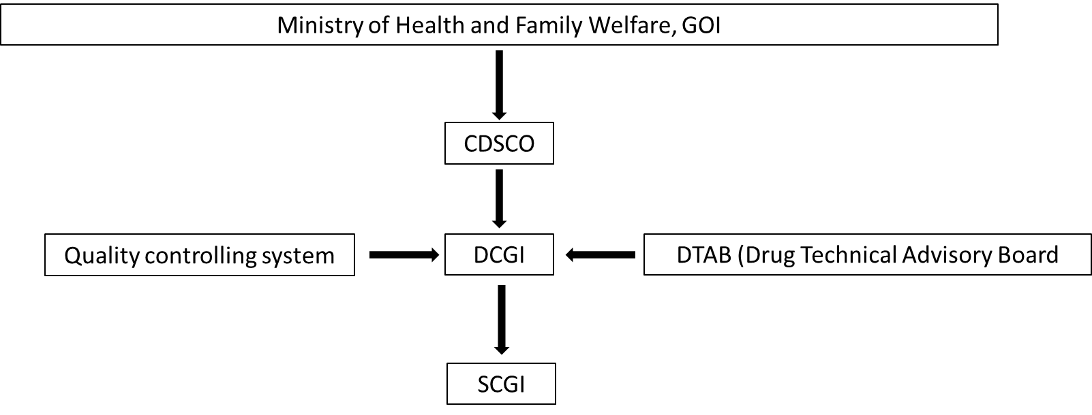Hierarchy’s are-

**Indian regulations and guidelines:**

1. **NPPA (National Pharmaceutical Pricing Authority):** Drugs (price control) order 1995 enforced by NPPA, GOI, view the cast of drugs under price control.
2. **D and C Act 1940 (The Drugs and Cosmetic Act) 1940:** Regulates the import, manufacture, distribution and scale of drugs in India.
3. **Schedule M:** Schedule M of the D.C. Act specifies the general and specific requirements for factory premises and materials, plant and equipment and minimum recommended areas for basic installation for certain categories of drugs.
4. **Schedule T:** Schedule T of D and C act prescribes 4 MP specifications of manufacture of Ayurvedic Siddha and Unani medicines.
5. **Schedule Y:** This schedule covers the clinical trials legislative requirements guided by this specification.
6. **GCP guidelines:** The Ministry of Health, DCGI and ICMR has come out with draft guidelines for research in human subjects. This GCP based on Declaration of Helsinki, WHO guidelines and ICH requirement for Good Clinical Practice (GCP).
7. **The Pharmacy Act 1948:** This is adopted to regulate the profession of pharmacy in India.
8. **The Narcotic Drugs and Psychotropic Substances Act 1985:** This act concerned with control and regulation of operation relating to Narcotic drugs and psychotropic substances.