ECO 403: FINANCE
Group B: Financial Economics
Topic 3: Portfolio Selection

What is Modern Portfolio Theory (MPT)?
Modern portfolio theory (MPT) is a theory on how risk-averse investors can construct portfolios to optimize or maximize expected return based on a given level of market risk, emphasizing that risk is an inherent part of higher reward. According to the theory, it's possible to construct an "efficient frontier" of optimal portfolios offering the maximum possible expected return for a given level of risk. This theory was pioneered by Harry Markowitz in his paper "Portfolio Selection," published in 1952 by the Journal of Finance. He was later awarded a Nobel prize for developing the MPT.

Portfolio Risk and Expected Return
MPT makes the assumption that investors are risk-averse, meaning they prefer a less risky portfolio to a riskier one for a given level of return. This implies that an investor will take on more risk only if he or she is expecting more reward.
The expected return of the portfolio is calculated as a weighted sum of the individual assets' returns. If a portfolio contained four equally-weighted assets with expected returns of 4, 6, 10, and 14%, the portfolio's expected return would be:
(4% x 25%) + (6% x 25%) + (10% x 25%) + (14% x 25%) = 8.5%
The portfolio's risk is a complicated function of the variances of each asset and the correlations of each pair of assets. To calculate the risk of a four-asset portfolio, an investor needs each of the four assets' variances and six correlation values, since there are six possible two-asset combinations with four assets. Because of the asset correlations, the total portfolio risk, or standard deviation, is lower than what would be calculated by a weighted sum.

Some important terms
Optimal portfolio: A portfolio that provides highest return and lowest risk is known as optimal portfolio.

Portfolio selection: The process of finding the optimal portfolio.

Portfolio Opportunity Set: Combining securities in different proportions, large number of portfolios can be created which forms the feasible set of portfolios/ portfolio opportunity set.

Efficient Portfolios: A portfolio having lower standard deviation and same expected return as the other or higher expected return and same standard deviation as the other.

Example-

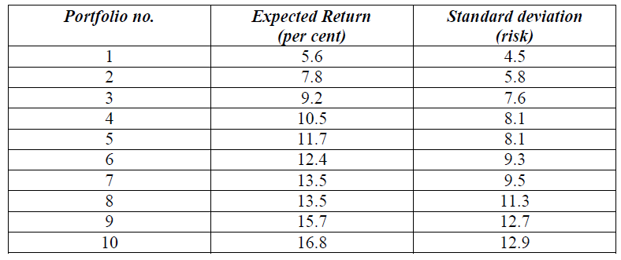

Diagrammatic presentation:
The expected return and standard deviation of portfolios can be depicted on an XY graph, measuring the expected return on the Y axis and the standard deviation on the X axis. Following figure depicts such a graph.

Figure 1

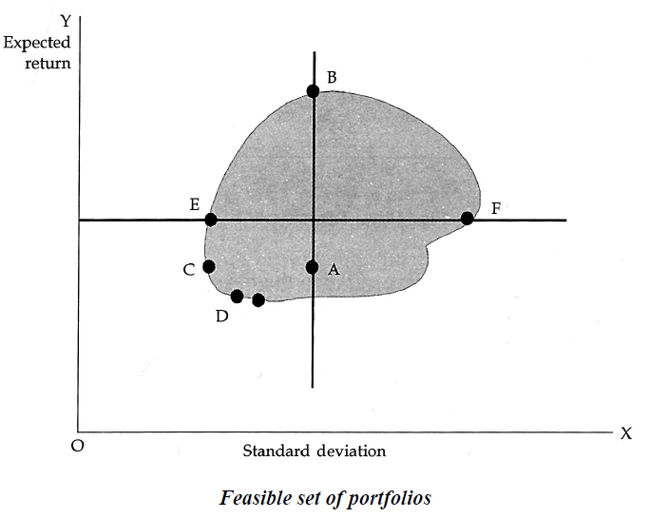

Each portfolio may be represented by a single point in the risk-return space enclosed within the two axes of the graph. The shaded area in the graph represents the set of all possible portfolios that can be constructed from a given set of securities. This opportunity set of portfolios takes a concave shape because it consists of portfolios containing securities that are less than perfectly correlated with each other.

Consider portfolios F and E→ Both the portfolios have the same expected return but portfolio E has less risk. Hence, portfolio E would be preferred to portfolio F.
Consider portfolios C and E→ Both have the same risk, but portfolio E offers more return for the same risk. Hence, portfolio E would be preferred to portfolio C.
Thus, for any point of risk-return space, an investor would like to move as far as possible in the direction of increasing returns and also as far as possible in the direction of decreasing risk. Effectively, he would be moving towards the left in search of decreasing risk and upwards in search of increasing returns.
Consider portfolios C and A→ Portfolio C would be preferred to portfolio A because it offers less risk for the same level of return.
In the opportunity set of portfolios represented in the diagram, portfolio C has the lowest risk compared to all other portfolios. Here portfolio C in this diagram represents the global minimum variance portfolio.
Comparing portfolios A and B→ Portfolio B is preferable to portfolio A because it offers higher return for the same level of risk. In this diagram, point B represents the portfolio with the highest expected return among all the portfolios in the feasible set.
Thus, we find that portfolios lying in the north-west boundary of the shaded area are more efficient than all the portfolios in the interior of the shaded area. This boundary of the shaded area is called the efficient frontier because it contains all the efficient portfolios in the opportunity set.
The set of portfolios lying between the global minimum variance portfolio and the maximum return portfolio on the efficient frontier represents the efficient set of portfolios. The efficient frontier is shown separately in the following figure:
Figure 2

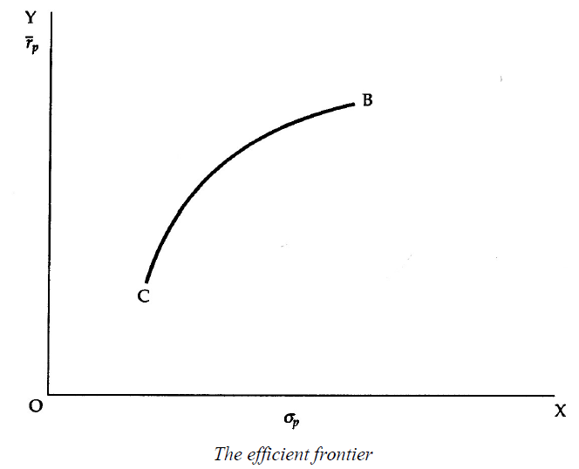
The efficient frontier is a concave curve in the risk-return space that extends from the minimum variance portfolio to the maximum return portfolio.
An investor is only interested with efficient portfolios.
It is assumed that the investors are rational and risk averse.

Efficient Frontier
Every possible combination of assets that exists can be plotted on a graph, with the portfolio's risk on the X-axis and the expected return on the Y-axis. This plot reveals the most desirable portfolios. For example, assume Portfolio A has an expected return of 8.5% and a standard deviation of 8%, and that Portfolio B has an expected return of 8.5% and a standard deviation of 9.5%. Portfolio A would be deemed more "efficient" because it has the same expected return but lower risk. It is possible to draw an upward sloping hyperbola to connect all of the most efficient portfolios, and this is known as the efficient frontier. Investing in any portfolio not on this curve is not desirable.

Selection of optimal portfolio:
The portfolio selection problem is really the process of delineating the efficient portfolios and then selecting the best portfolio from the set. Rational investors will obviously prefer to invest in the efficient portfolios. The particular portfolio that an individual investor will select from the efficient frontier will depend on that investor‘s degree of aversion to risk. A highly risk averse investor will hold a portfolio on the lower left hand segment of the efficient frontier, while an investor who is not too risk averse will hold one on the upper portion of the efficient frontier. The selection of the optimal portfolio thus depends on the investor ‘s risk aversion, or conversely on his risk tolerance. This can be graphically represented through a series of risk return utility curves or indifference curves. The indifference curves of an investor are shown in the figure below. Each curve represents different combinations of risk and return all of which are equally satisfactory to the concerned investor. The investor is indifferent between the successive points in the curve. Each successive curve moving upwards to the left represents a higher level of satisfaction or utility. The investor ‘s goal would be to maximise his utility by moving upto the higher utility curve. The optimal portfolio for an investor would be the one at the point of tangency between the efficient frontier and the risk-return utility or indifference curve. This is shown in the following figure. The point O‘ represents the optimal portfolio.

Figure 3.

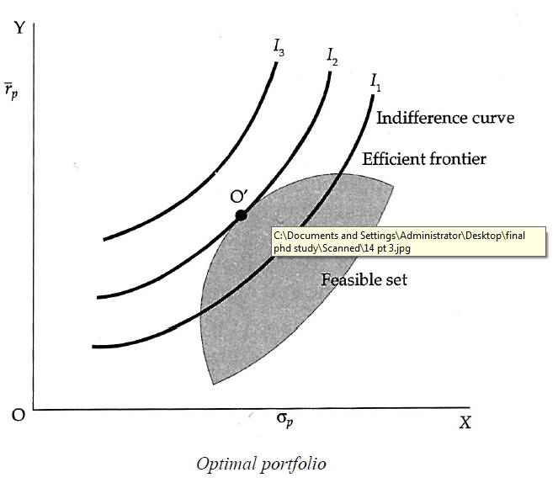
Limitations of Markowitz model
- Large number of data required for calculation
- Complex Computations required.

The simplification is obtained by index models: single index and multi-index model.

CAPM
The capital asset pricing model or CAPM is an extension of Markowitz theory.
CAPM derives the relationship between the expected return and risk of individual securities and portfolios in the capital markets if everyone behaved in the way the portfolio theory put forward.

