**Clinical Nutrition and dietetics – 2nd semester**

**Paper No.: CND 201**

**Name of the paper: STATISTICS AND COMPUTER APPLICATION**

**Topic: Experimental research design**

**Lecture No.: 5**

**Lecture prepared by Prof. Debidas Ghosh**

**Experimental Research Design (ERD)**

1. **Background:** It is centrally concerned with constructing research which is high in internal validity. It is the lagging out of a detailed experimental plan in advance of doing the experiment.
2. **Definition:** ERD is the brunch of statistics that deals with the design and analysis of experiments through scientific planing for exploring the effect of one or more chosen independent variables on a specific dependent variable. It is applicable in medicine, biology, agriculture, marketing research and industrial production.
3. **Types:** There are four types of ERD.
4. **Independent group experiment:** Steps are-

* Individuals are randomly selected from the population depending on the laws of probability.
* None of the groups include any individual, common two or associated with the other groups.
* The groups may be identical or different sizes large group – not less than 30 cases ( n > 30), small group – lower than 30 (n < 30).
* 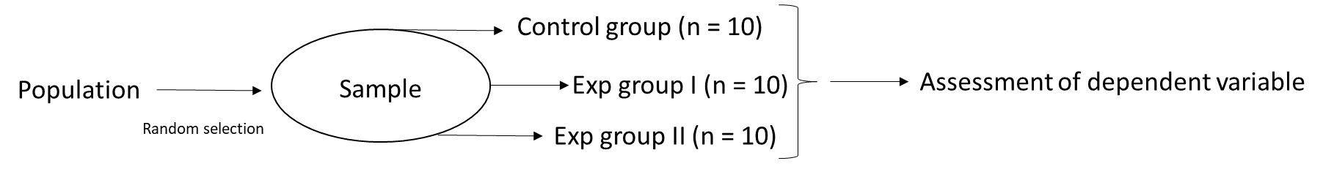One of these groups called the control group would be expressed to a treatment known as experimental groups. Numbers of experimental groups depends on the level of independent variable. If three levels are applied then three experimental groups are designed.

1. **Single group experiment:** Same group of individuals randomly sampled from a population, serves first at the control group and subsequently as the experimental group.

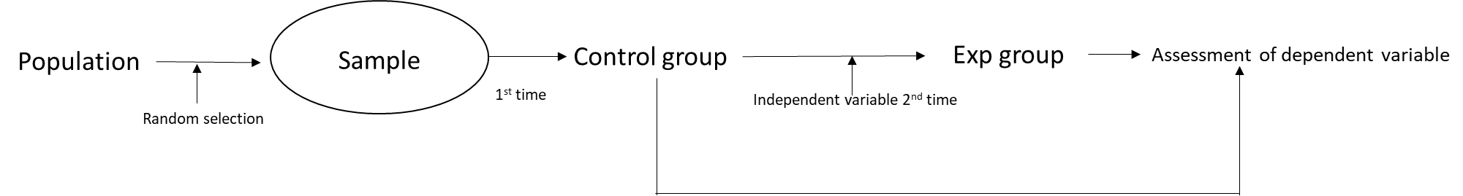

1. **Matched pair equivalent group experiment:**

* Samples are selected randomly from the population.
* On the basis of interested variables and on pair matching about the level of variable the individual one is placed in placebo group and matched individual placed in experimental group.
* This process is repeated until desire size of placebo and experimental group is achieved.
* 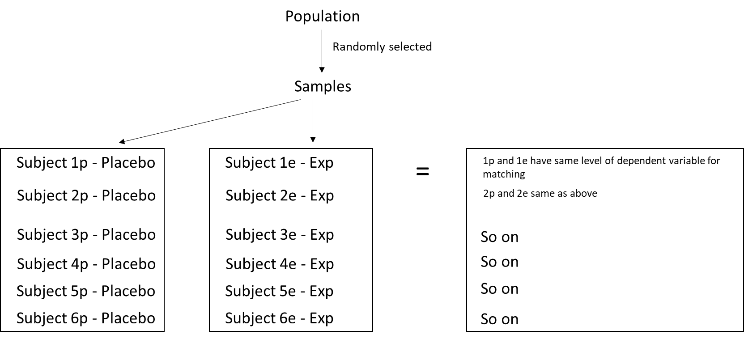Now independent variable is applied on experimental group and through assessment of dependent variable levels in placebo and experimental group, the effect of independent variables on dependent can be noted.

1. **Randomized Block Experiment (RBE):**

* Samples are drawn at random from population.
* The design has ‘r’ number of classes and/blocks.
* Sample (n) is divided in ‘r’ number of blocks.
* Each block consists of K number of individuals.

So, n = r × K

* The individual of each block are allocated at random to different levels of treatment so that-

1. Each level of treatment is applied on only are individuals of each block.
2. All the levels are applied on one or other of the number of each block.

* The dependent variable scores are finally measured in all the individual of each block.
* 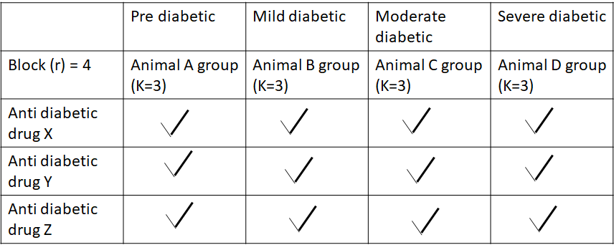The scores of the different groups are then compared and analysed statistically.