**Biomedical Laboratory Science and Management – 4th semester**

**Paper No.: BMLS&M 404**

**Name of the paper: Clinical research and bioinformatics**

**Topic: Pharmacokinetics with special reference to bioavailability**

**Lecture No.: 3**

**Lecture prepared by Prof. Debidas Ghosh**

**Pharmacokinetics with special reference to bioavailability**

**Definition:**

It is a branch of pharmacology dedicated to determine the fate of substances administered to a living organism. The substances of interest include – Pharmaceutical drugs, pesticides, food additives, cosmetics etc. It covers the fate of chemicals from the moment of administration up to the point at which it is eliminated from the body completely. So, PK is the study of how an organism affects a drug, where as pharmacodynamics (PD) is the study of how the drug affects the organism.

**PK covered the following steps as per IUPAC:**

1. Uptake of the drugs by the body.
2. Absorption and transportation of the drug.
3. Biotransformation of the drug.
4. Availability of the drug metabolites in target tissue.
5. Elimination of the drug and there metabolites from the body over a period of time.

In short, PK cover four process known as ADME where A = Absorbtion, D = Distribution, M = Metabolism, E = Elimination. The primary goal of PK includes enhancing efficacy and decreasing toxicity of a patient’s drug therapy.

**Bioavailability:**

**Definition:**

Proportion of the administered drug that reaches its site of action.

It expressed by a formula: De = B **.** Da

Where De = Effective dose of the drug. B = Bioavailability. Da = Administered Dose.

If a drug has a bioavailability of 0.8 (80%) and it is administered in a dose of 100 mg, the equation will demonstrate the following.

De = 0.8 × 100 mg = 80 mg, i.e. effective dose is 80 mg that has the capacity to have a pharmaceutical effect.

**Classifications:**

1. Pharmaceutical form.
2. Chemical form.
3. Route of administration.
4. Stability.
5. Metabolism.

So De = Q **.** Da **.** B

When Q = Drugs purity

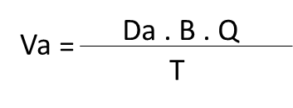

Va = Drugs rate of administration

T = Rate at which the absorbed drug reaches the circulatory system.

When two drugs have the same bioavailability, they are said to be biological equivalents or bioequivalent.

This bioequivalent is important because it is currently used as yardstick in the authorization of generic drugs in many countries.  
Intravenous administration of drug provides greatest possible bioavailability and this method is considered to yield a bioavailability of 1 (100%).

* Bioavailability of other delivery methods is compared with that of intravenous injections known as absolute bioavailability.
* When bioavailability is compared to a standard value known as relative bioavailability.

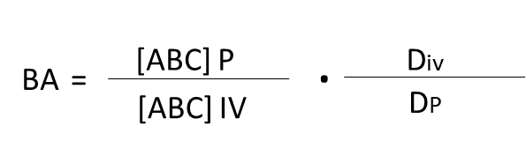

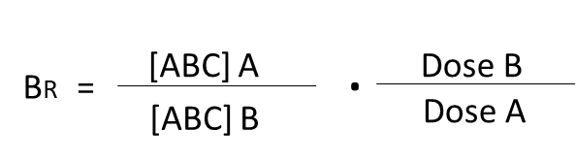

Where BA = Absolute bioavailability

BR = Relative bioavailability