Biomedical Laboratory Science and Management – 2nd semester
Paper No.: BMLS&M 201
Name of the paper: Reproductive Events and Assisted Reproductive Technology
Topic: Antisperm Antibodies (ASA) and Infertility
Lecture No.: 4
Lecture prepared by Prof. Debidas Ghosh

Antisperm Antibodies (ASA) and Infertility
- Introduction: ASA has long been noted by Landsteiner and Matchnikoff in 1899. The presence of ASA raised the question of whether such antibodies could cause male infertility. In 1959 Rumke and Hellinger noted the presence of auto antibodies against spermatozoa in a significant number of men with infertility. In the same year Katsh referred that infertility could be induced in female guineapigs by intraperitoneal injection of homologues sperm.
- Types of distribution of ASA: There are three major structural types of antisperm immunoglobulins in human. These are IgG, IgA and IgM. IgG and IgA are the two major immuno globulin classes of antisperm antibodies in the sera of immuno logically infertile couples.
In the reproductive tract, IgA is the major immunoglobulin and is produced by plasma cells and epithelial cells. The reproductive tract antibodies differ from circulating antibodies in their relative immuno globulin concentration and in the structure of immuno globulins. Estradiol low level declines IgG and IgA synthesis in uterus, cervix and fallopian tube.
- Laboratory test for analysis of ASA:
- Sperm agglutination test (SAT)
- Franklin-Dukes test.
- Kibrick’s gelatine test.
- Mixed agglutination Reaction (MAR)
- Immuno Bead Test (IBT)
- Direct.
- Indirect.
- Enzyme Linked Immuno Sorbent Assay (ELISA).
- Immuno Fluorescence Test (IFT).
- IBT: This test uses Rabbit Antihuman Immunoglobulin-Linked polyacrylamide micro spheres as immunobeads. The immunobeads will adhere to the surface of the sperm that are antibodies-bound. Distribution IgG, IgA and IgM at different parts of sperm can be assessed by IBT.
- In direct IBT, detection of antibodies bound to the surface of motile sperm can be perform.
- In indirect IBT, the detection of antisperm antibodies in serum against sperm antigen can be performed.

Quantification of ASA is done by visualisation of beads bound to the sperm surface.

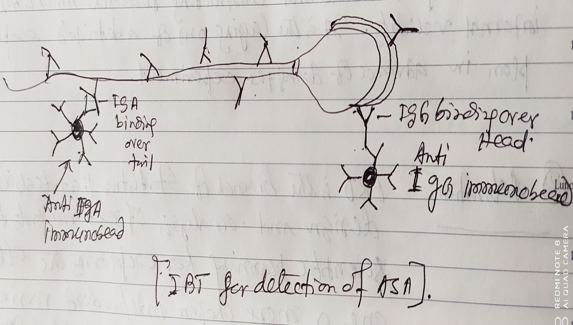
Along the head surface of sperm, mainly IgG antibodies are present but along the tail part of sperm, IgA antibody is present.
- Potential influences of ASA on human:
- Interference with sperm production by the testes.
- Restriction of the capability of sperm to penetrate or survive in cervical mucus.
- Reduction of the sperm motility and hindering of its transport.
- Damage of the integrity of sperm plasma membrane.
- Interference with sperm capacitation and or acrosome reaction.
- Interference with sperm Zona pellucida binding and/ or penetration.
- Inhibition of sperm oolemma fusion.
- Inhibition of early cleavage of fertilized eggs.
- Suppression of the development of embryos.

