Course: M.Phil. 2nd semester, Life Science
Paper No.: L.Sc 123
Paper Name: Structural elucidation of biomolecules
Topic: Steroid Hormone
Lecture No.: 1
Prepared by: Prof. Debidas Ghosh

Steroid hormone receptor:
- Location: Steroid hormone receptors are mobile model receptors and they are distributed either in cytoplasm or nucleoplasm of the target cell. After formation of hormone-receptor complex at cytoplasm, it never from non genomic compartment to genomic compartment of the target cell and modulate the cellular function by altering gene expression.
- Evidence for movement of steroid H-R complex from cytoplasm to nucleoplasm: Fallopian epithelial cells of avian species are to culture in presence of radiolabel progesterone and at different time intervals, few cells are collected from experimental groups. Duration dependent radioactivity of cytoplasmic and nucleoplasmic compartments is assessed by scintillation centre. It has been indicated that for first 10-15 minutes, the maximum radio activity is confined in cytoplasmic compartment but nucleoplasmic compartment remains non radioactive. In contrast, after 20 minutes, the radioactivity is shifted from cytoplasmic to nucleoplasmic compartment. Such shifting of radioactivity focusing the facts that steroid H-R complex is first formed in cytoplasm and then it is shifted to nucleoplasm. This receptor is protein in nature proved by protease treatment.
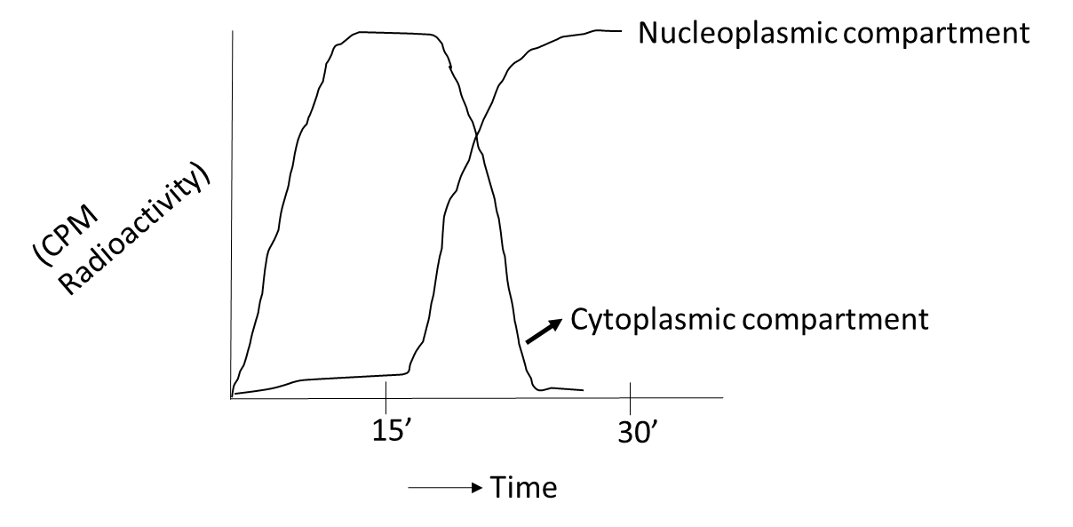

- Progesterone receptor in cytoplasm:
- Progesterone receptor in cytoplasm is a timer consists of monomer A and monomer B. Each monomer has binding affinity to one molecule of progesterone. This hetarodimeric progesterone receptor after binding with progesterone molecule can able to migrate from cytoplasm to nucleoplasm and bind with steroid response element (SRE).

- After binding to the SRE, the monomer A with steroid molecule remains there but B monomer or sub unit with progesterone molecule search out the initiation site of ovalbumin gene and bind there with acidic protein-3 known as AP3. From hybridization technique of AP3 of progesterone target and non target cells it has been noted that when AP3 is allow for cross hybridization between non target and target cells of progesterone, then the target cell become unable to express the ovalbumin gene.

- Binding of sub unit B with progesterone at AP3 site results opening of initiation sites for entry of DNA directed RNA polymerase and start the gene expression. It has been proved by the fact that is tissue culture when progesterone target cells are pre incubated with gentamycin to block the initiation site, ovalbumin gene expression in follicular epithelial cells in presence of progesterone is not happened.

