Clinical Nutrition and dietetics – 2nd semester
Paper No.: CND 201
Name of the paper: STATISTICS AND COMPUTER APPLICATION
Topic: Regression and prediction
Lecture No.: 1
Lecture prepared by Prof. Debidas Ghosh

Introduction:
- Regression is prediction statistics which predicts the value of ‘dependent variable’ or ‘criterion’ on the basis of the given value(s) of ‘independent variable’ or ‘predictor’ and regression can be computed only when dependent and independent variable(s) posse’s significant correlation with each other.
- It translates the relation between or among variables into expression focusing one of them as function of the other(s).
- Regression holds good only for the limited range of scores of the variables from which it has been derived; it can not be extended beyond this limits.
Types of Regression:
- On the basis of numbers of independent variable:
- Simple regression: When the scores of the dependent variable or criterion are predicted from the given scores of single independent variable or predictor. Example – The regression of hight of an individual on his weight, the regression of oxygen transporting amount of haemoglobin level.
- Multiple regression: The scores of the dependent variable or criterion are predicted from the given scores of more than one independent variable or predictor. Example – The regression of body surface area of an individual on his height and weight.
- On the basis of the nature of graphics of regression:
- Linear regression: It expresses the dependent variable Y as the linear function of the independent variable X. the scattergram of the scores of dependent variable plotted against the scores of independent variable reflects a linear distribution of its plotted points.
- Non linear regression: The scattergram show a curvilinear distribution like elliptical, hyperbolic etc.
Models of regression:
On the basis of the nature of independent variable, regression is of 3 models.
- Model I regression: It is the regression of dependent variable (Y) on an independent variable which is a ‘fixed’ treatment variable or ‘controlled’ treatment variable which is under deliberate predetermined and precise manipulation of the investigator.
The independents variables are not allowed to change, vary or fluctuate at random. They thus do not suffer from random errors during the experiment.
A model I regression is used to predict the value of Y for specific value of X when the X or predictor is varied by the observer at precise and predetermined manners. The values of Y suffer errors due to random variations bur the values of the ‘fixed’ treatment variable i.e. X are free from random errors. So model I regression an estimate the cause and effect relation between dependent and independent variables.
Model I regression is of two types i.e.
- Simple Model I regression where the single predictor is fixed treatment variable.
- Multiple Model I regression where two or more than two predictors are fixed treatment variable.
- Model II regression: This is the regression of a criterion (Y) on an predictor (X) which is a classification variable i.e. they are not directly controlled or fixed by deliberate manipulation by the investigator. They change at random due to their inherent nature. So, predictors are liable to random errors as well as criterion also has random errors. Hence, Model II regression can not explore the cause and effect relation between the variables.
Example: i. The regression of cardiac stroke volume on venous return. ii. The regression of glomerular filtration rate on glomerular blood pressure.
It is of two types:
- Simple Model II regression where single predictor is classification variable like glomerular blood pressure.
- Multiple Model II regression where two or more than two predictors are classification variable.
Example: Body surface area on height and weight of the individual.
- Model III Regression: This is also known as mixed model regression and it is always multiple regressions. Two or more than two independent variables are included where one or more than one is/are fixed treatment variable and other are classification variables.
Example: Regression of blood thyroxine level on combination of atmospheric temperature (classification variable) and injected dose of TSH (fixed treatment variable).
Assumption of simple linear regression:
- The variables involved are either continuos measurement variables or apparently discrete variables but yield continuous metric scores on further exploration.
- Both the variable has unimodal and fairly symmetrical distribution.
- There is a significant product moment r between the variables and their scattergram has a linear distribution.
Computation:
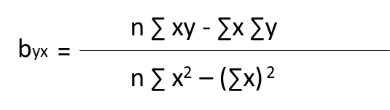
- Regression coefficient by X for the regression of Y on X is computed by

Or
Using Product moment r
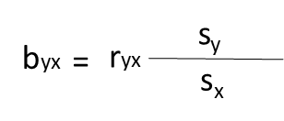

- Regression of X on Y
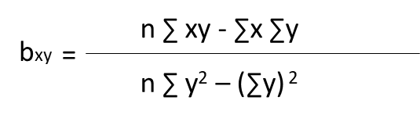

- The statistics a_{yx} is the Y intercept of the regression line of Y on X
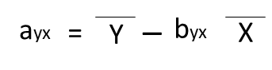

- The regression equitation of X on Y
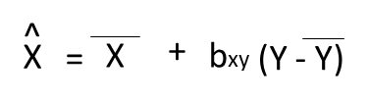

- The regression equitation of Y on X
