Most Popular Remote Sensing and GIS software

A remote sensing software is a software application that processes remote sensing data. Remote sensing applications are similar to graphics software, but they enable generating geographic information from satellite and airborne sensor data. Remote sensing applications read specialized file formats that contain sensor image data, georeferencing information, and sensor metadata. Some of the more popular remote sensing file formats include: GeoTIFF, NITF, JPEG 2000, ECW (file format), MrSID, HDF, and NetCDF.
Remote sensing applications perform many features including:
Change Detection — Determining the changes from images taken at different times of the same area
Orthorectification — Warping an image to its location on the earth
Spectral Analysis — For example, using non-visible parts of the electromagnetic spectrum to determine whether a forest is healthy
Image Classification — Categorizing pixels based upon reflectance into different land cover classes (e.g. Supervised classification, Unsupervised classification and Object Oriented classification)
Many remote sensing applications are built using common remote sensing toolkits, like GDAL and OSSIM.
Examples of remote sensing software[edit]
Geomatica, PCI Geomatics
SAGA GIS (Open Source)
TNTmips gis, MicroImages,USA
ERDAS IMAGINE
ENVI
Google Earth
GRASS GIS
OpenEV (Open Source)
Opticks (Open Source)
Orfeo toolbox (Open Source)
RemoteView
SOCET SET
IDRISI
ECognition
ArcGIS

What is GIS Software?
GIS software is a computer-based tool for examining geographic patterns, trends and relationships. They allow organizations to store, analyze and visualize data for geographic locations anywhere on Earth. By connecting geography with data, you understand data through a geographic context.
Mapping Out the GIS Software Landscape
ArcGIS, QGIS, GRASS GIS, SuperGIS, SAGA GIS, JUMP GIS…
The GIS software options out there seem endless.
Don’t worry. Because today, you get a sneak peek at the top GIS software packages the industry is adopting.

From best to worst, here they are:
1 ArcGIS Pro
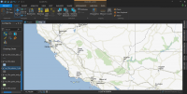
ArcGIS Pro modernizes GIS with a ribbon interface, 64-bit processing and 3D integration. It’s a massive overhaul with a focus on quickness, ingenuity and cartography. Even though ArcGIS Pro is a big machine with lots of moving parts, it earns top spot.
2 ArcGIS Desktop
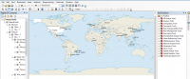
ArcGIS Desktop is cutting edge in GIS. It raises the bar to the next level by doing what other GIS software can’t. Its success is that it’s expandable. From field apps to modeling and scripting, ArcGIS is a powerhouse for all things GIS.

REVIEW: ArcGIS Review: Is ArcMap the Best GIS Software?
3 QGIS 3
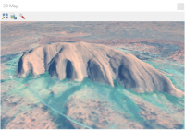
Open source flows in the DNA of QGIS 3. It’s been genetically tailored to break the mould of commercial GIS. Not only because it’s now in 3D. But QGIS plugins still give you the power to analyze like the Incredible Hulk.

REVIEW: The Hidden Powers of QGIS 3
4 QGIS 2
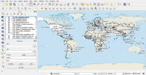

QGIS 2 is the largest community effort in the history of GIS. And because it’s community-driven, it’s wildly innovative and inventive. Even though QGIS 2 is completely open source, it still rivals the best.

REVIEW: QGIS 2 Review (Quantum GIS)
5 Hexagon Geomedia
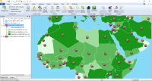
GeoMedia has 40+ years of history. But lately, it’s taken a bit of a slide. Nevertheless, it’s still solid as GIS software. Especially, when you pair it up with ERDAS Imagine, you get arguably the best suite in remote sensing.

REVIEW: 9 Powerful Features of GeoMedia by Hexagon Geospatial
6 MapInfo Professional
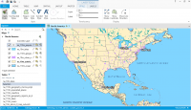
At its core, MapInfo Professional is all about locational intelligence. And just like GeoMedia, it’s been a tale of shrinking market share. But don’t get fooled. MapInfo is still gifted as an well-rounded GIS software suite.

REVIEW: MapInfo Professional by Pitney Bowes
7 FME® Feature Manipulation Engine
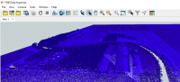
Feature Manipulation Engine FME® isn’t a full-fledged GIS package. Instead, it wrangles and slays your data like a Jedi. It’s extremely powerful and has a surprisingly active community. In fact, its yearly World Tour is a blast to attend. But just don’t use FME® for making maps.
REVIEW: FME Software – Feature Manipulation Engine
8 Global Mapper
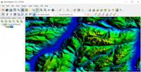
Global Mapper is like a “Swiss army knife” in GIS analysis. It’s straight-forward to get started. But at the same time, it has an incredible amount of flexibility. For example, it has powerful display for LiDAR and elevation.

REVIEW: Global Mapper Software by Blue Marble
9 gvSIG
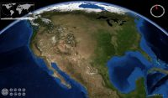
If you eat, sleep and breathe GIS, gvSIG is free and open source GIS software. Its features may surprise you. For example, it has a field app, 3D capabilities and a desktop application. But it’s light on documentation. Especially, anything in English.

REVIEW: gvSIG Software Review: Desktop, 3D and Mobile GIS
10 GRASS GIS
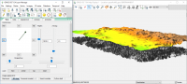

GRASS GIS is one of those suites that let you geoprocess until the night falls. It’s a loaded gun with sophisticated tools. It’s so powerful that you can unleash GRASS GIS in QGIS as a separate toolbox. But its clunky interface and stubborn map projection rules hold it back.

REVIEW: GRASS GIS – Geographic Resources Analysis Support System

