CAPITAL ASSET PRICING MODEL
By Will Kenton, Akhilesh Ganti & James Chen
[reviewed & edited by Kalpataru Bandopadhyay]
To understand the concept of Capital Asset Pricing Model (CAPM), it is better to have idea about evolution of the Capital Asset Pricing Model.
Evolution of capital Asset Pricing Model:
• Mean-variance analysis was pioneered by Harry Markowitz and James Tobin
• The efficient frontier of optimal portfolios was identified by Markowitz in 1952
• James Tobin included the risk-free rate to modern portfolio theory in 1958
• William Sharpe then developed the CAPM in the 1960s, and won a Nobel prize for his work in 1990, along with Markowitz and Merton Miller.
The above concepts would be discussed in the following sections.
An investor would choose different securities to invest in with different levels of expected return and risk associated with it. An investor may be ignorant about the concept of risk but modern portfolio theory considers risk as an integral part of investment decision. The expected return is estimated out of the average return yielded by similar type of investment in recent past. The risk is estimated out of variance of return of the concerned project. Investors use mean-variance analysis to make decisions about which financial instruments to invest in, depending on how much risk they are willing to take against different levels of return or reward. In other words, mean-variance analysis allows investors to find the highest return at a given level of risk or the least risk at a given level of return.

FIG-1
Mean-variance assumes that investors will make rational decisions. Thus one assumption is that investors want low risk and high reward. If two different securities have the same expected return, but one has lower variance, the one with lower variance is the better pick. Similarly, if two different securities have approximately the same variance, the one with the higher return is the better pick.
In Fig-1 there are eight investment options with different risk-return combination. To understand which investment options should be considered, the discussion of efficient frontier would be helpful.

Efficient Frontier
The efficient frontier is the set of optimal portfolios that offer the highest expected return for a particular level of risk. The efficient frontier also helps in finding portfolio at the lowest risk for a particular level of expected return. Portfolios that lie below the efficient frontier are sub-optimal because they do not provide enough return for the level of risk. Portfolios that cluster to the right of the efficient frontier are sub-optimal because they have a higher level of risk for the defined rate of return.
Efficient Frontier Explained:
The efficient frontier rates portfolios (investments) on a scale of return (y-axis) versus risk (x-axis). Compound Annual Growth Rate (CAGR) of an investment is commonly used as the return component while standard deviation (annualized) depicts the risk metric. The efficient frontier theory was introduced by Nobel Laureate Harry Markowitz in 1952 and is a cornerstone of modern portfolio theory (MPT).
The efficient frontier graphically represents portfolios that maximize returns for the risk assumed. Returns are dependent on the investment combinations that make up the portfolio. The standard deviation of a security is synonymous with risk. Ideally, an investor seeks to populate the portfolio with securities offering exceptional returns but whose combined standard deviation is lower than the standard deviations of the individual securities. The less synchronized the securities (lower covariance) then the lower the standard deviation. If this mix of optimizing the return versus risk paradigm is successful then that portfolio should line up along the efficient frontier line.

Fig-2

A key finding of the concept was the benefit of diversification resulting from the curvature of the efficient frontier. The curvature is integral in revealing how diversification improves the portfolio's risk / reward profile. It also reveals that there is a diminishing marginal return to risk. The relationship is not linear. In other words, adding more risk to a portfolio does not gain an equal amount of return. Optimal portfolios that comprise the efficient frontier tend to have a higher degree of diversification than the sub-optimal ones, which are typically less diversified.

Optimal Portfolio
One assumption in investing is that a higher degree of risk means a higher potential return. Conversely, investors who take on a low degree of risk have a low potential return. According to Markowitz's theory, there is an optimal portfolio that could be designed with a perfect balance between risk and return. The optimal portfolio does not simply include securities with the highest potential returns or low-risk securities. The optimal portfolio aims to balance securities with the greatest potential returns with an acceptable degree of risk or securities with the lowest degree of risk for a given level of potential return. The points on the plot of risk versus expected returns where optimal portfolios lie are known as the efficient frontier.
Selecting Investments
Assume a risk-seeking investor uses the efficient frontier to select investments. The investor would select securities that lie on the right end of the efficient frontier. The right end of the efficient frontier includes securities that are expected to have a high degree of risk coupled with high potential returns, which is suitable for highly risk-tolerant investors. Conversely, securities that lie on the left end of the efficient frontier would be suitable for risk-averse investors.
Limitations
The efficient frontier and modern portfolio theory have many assumptions that may not properly represent reality. For example, one of the assumptions is that I) asset returns follow a normal distribution. However, asset returns are said to follow a leptokurtic distribution or heavy-tailed distribution. Additionally, Markowitz considers several assumptions in his theory, such as i) investors are rational and ii) avoid risk when possible; iii) there are not enough investors to influence market prices; and iv) investors have unlimited access to borrowing and lending money at the risk-free interest rate. So, the concept of efficient frontier suffers from some limitations. The efficient frontier demonstrates the several equivalent options investment opportunities in risky assets. However, an investor may invest in risky assets along with risk-free assets. In the next section, there would be a discussion on Capital Allocation Line to understand optimal combination of risky assets and risk-free rate of return.
Capital Allocation Line (CAL):
The capital allocation line (CAL) is a line created on a graph of all possible combinations of risk-free and risky assets. The graph displays the return investors might possibly earn by assuming a certain level of risk with their investment. The slope of the CAL is known as the reward-to-variability ratio. The capital allocation line aids investors in choosing how much to invest in a risk-free asset and one or more risky assets. Asset allocation is the allotment of funds across different types of assets with varying expected risk and return levels, whereas capital allocation is the allotment of funds between risk-free assets, such as certain Treasury securities, and risky assets, such as equities.

Constructing Portfolios With the CAL
An easy way to adjust the risk level of a portfolio is to adjust the amount invested in the risk-free asset. The entire set of investment opportunities includes every single combination of risk-free and risky assets. These combinations are plotted on a graph where the y-axis is the expected return and the x-axis is the risk of the asset as measured by the standard deviation.
The simplest example is a portfolio containing two assets: a risk-free Treasury bill and a stock. Assume that the expected return of the Treasury bill is 3% and its risk is 0%. Further, assume that the expected return of the stock is 10% and its standard deviation is 20%. The question that needs to be answered for any individual investor is how much to invest in each of these assets. The expected return (ER) of this portfolio is calculated as follows:

Expected Return of portfolio = Expected Return of risk-free asset x weight of risk-free asset + Expected Return of risky asset x (1- weight of risk-free asset)

The calculation of risk for this portfolio is simple because the standard deviation of the Treasury bill is 0%. Thus, risk is calculated as:

Risk of portfolio = weight of risky asset x standard deviation of risky asset

In this example, if an investor were to invest 100% into the risk-free asset, the expected return would be 3% and the risk of the portfolio would be 0%. Likewise, investing 100% into the stock would give an investor an expected return of 10% and a portfolio risk of 20%. If the investor allocated 25% to the risk-free asset and 75% to the risky asset, the portfolio expected return and risk calculations would be:

Expected Return of Portfolio = (3% x 25%) + (10% * 75%) = 0.75% + 7.5% = 8.25%
Risk of portfolio = 75% * 20% = 15%

The Slope of the CAL
The slope of the CAL measures the trade-off between risk and return. A higher slope means that investors receive a higher expected return in exchange for taking on more risk. The value of this calculation is known as the Sharpe ratio.

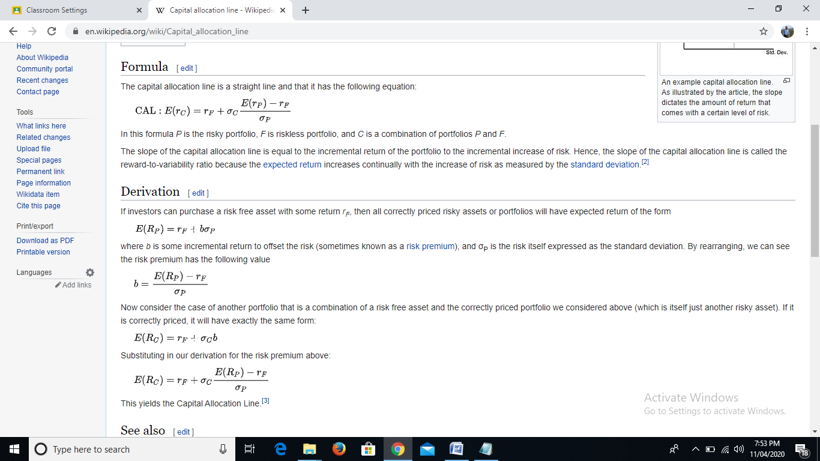

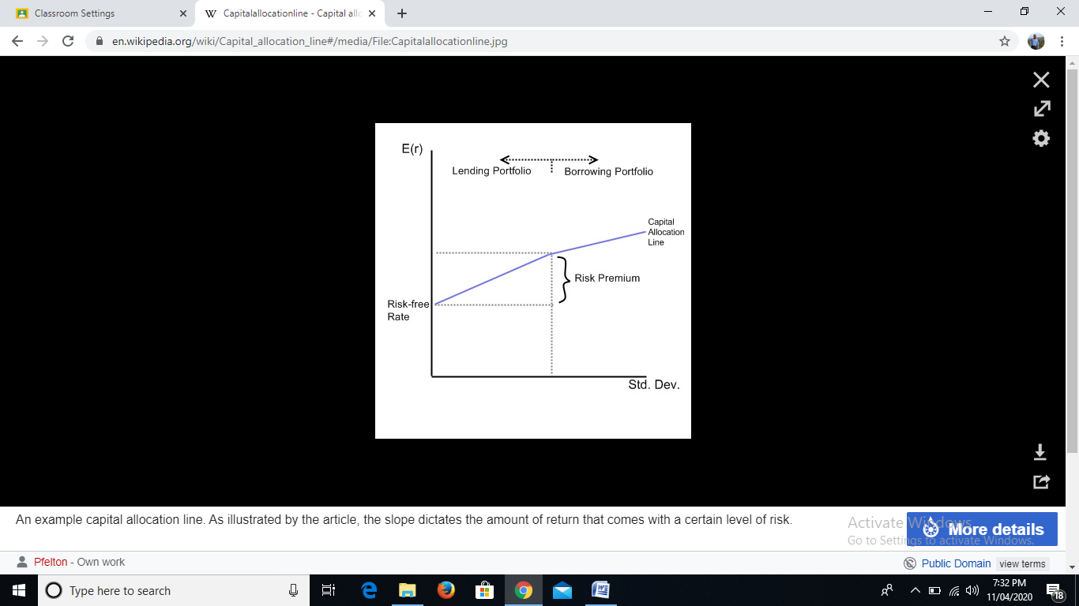

Capital Market Line (CML)
The capital market line (CML) represents portfolios that optimally combine risk and return. Capital market line is special case of Capital Allocation Line where risk-free rate of return touches at market portfolio (remember not any other investment option with different risk-return combination). Capital asset pricing model (CAPM), depicts the trade-off between risk and return for efficient portfolios. It is a theoretical concept that represents all the portfolios that optimally combine the risk-free rate of return and the market portfolio of risky assets. Under CAPM, all investors will choose a position on the capital market line, in equilibrium, by borrowing or lending at the risk-free rate, since this maximizes return for a given level of risk.

Understanding the Capital Market Line (CML):
Portfolios that fall on the capital market line (CML), in theory, optimize the risk/return relationship, thereby maximizing performance. The capital allocation line (CAL) makes up the allotment of risk-free assets and risky portfolio for an investor. CML is a special case of the CAL where the risk portfolio is the market portfolio. Thus, the slope of the CML is the sharpe ratio of the market portfolio. As a generalization, buy assets if the Sharpe ratio is above the CML and sell if the Sharpe ratio is below the CML.
CML differs from the more popular efficient frontier in that it includes risk-free investments. The intercept point of CML and efficient frontier would result in the most efficient portfolio, called the tangency portfolio. CAPM and the associated efficient frontier can help investors understand the relationship between expected risk and reward as they make better decisions about adding securities to a portfolio.
The CAPM, is the line that connects the risk-free rate of return with the tangency point on the efficient frontier of optimal portfolios that offer the highest expected return for a defined level of risk, or the lowest risk for a given level of expected return. The portfolios with the best trade-off between expected returns and variance (risk) lie on this line. The tangency point is the optimal portfolio of risky assets, known as the market portfolio. Under the assumptions of mean-variance analysis – that investors seek to maximize their expected return for a given amount of variance risk, and that there is a risk-free rate of return – all investors will select portfolios which lie on the CML.
The individual investors will either hold just the risk-free asset or some combination of the risk-free asset and the market portfolio, depending on their risk-aversion. As an investor moves up the CML, the overall portfolio risk and return increases. Risk averse investors will select portfolios close to the risk-free asset, preferring low variance to higher returns. Less risk averse investors will prefer portfolios higher up on the CML, with a higher expected return, but more variance. By borrowing funds at the risk-free rate, they can also invest more than 100% of their investable funds in the risky market portfolio, increasing both the expected return and the risk beyond that offered by the market portfolio.
So far we have discussed about total risk which is represented by small sigma. However, total risk could be segregated into two types of risk: systematic risk and unsystematic risk. The systematic risk refers to risk related to market. The chance of a pandemic or breaking out of a war or even natural calamities or unforeseen events could lead to huge fall in the market. All most all the shares would be negatively affected. On the other hand unsystematic risk refers to risk related to that particular company. If the an efficient CEO resigns or the company gets a huge long term export order the share price would affect negatively in first case and positively in second case. A portfolio manager can diversify his portfolio by investing in different securities to reduce risk. With diversification, a portfolio manager can reduce the unsystematic risk only. The market risk or systematic risk can not be reduced.
In this context, CAPM shows the interaction between efficient frontier and security market line (SML). This security market line represents unsystematic risk

The Capital Market Line and the Security Market Line
The CML is sometimes confused with the security market line (SML). The SML is derived from the CML. While the CML shows the rates of return for a specific portfolio, the SML represents the market’s risk and return at a given time, and shows the expected returns of individual assets. And while the measure of risk in the CML is the standard deviation of returns (total risk), the risk measure in the SML is systematic risk, or beta. Securities that are fairly priced will plot on the CML and the SML. Securities that plot above the CML or the SML are generating returns that are too high for the given risk and are underpriced. Securities that plot below CML or the SML are generating returns that are too low for the given risk and are overpriced.

Capital Asset Pricing Model
The CAPM uses the principles of Modern Portfolio Theory to determine if a security is fairly valued. It relies on assumptions about investor behaviors, risk and return distributions, and market fundamentals that don’t match reality. The Capital Asset Pricing Model (CAPM) describes the relationship between systematic risk and expected return for assets, particularly stocks. CAPM is widely used throughout finance for pricing risky securities and generating expected returns for assets given the risk of those assets and cost of capital. The formula for calculating the expected return of an asset given its risk is as follows:
The investors expectation is to be compensated for risk and the time value of money. The risk-free rate in the CAPM formula accounts for the time value of money. The other components of the CAPM formula account for the investor taking on additional risk.
The beta of a potential investment is a measure of how much risk the investment will add to a portfolio that looks like the market. If a stock is riskier than the market, it will have a beta greater than one. If a stock has a beta of less than one, the formula assumes it will reduce the risk of a portfolio.
A stock’s beta is then multiplied by the market risk premium, which is the return expected from the market above the risk-free rate. The risk-free rate is then added to the product of the stock’s beta and the market risk premium. The result should give an investor the required return or discount rate they can use to find the value of an asset. The goal of the CAPM formula is to evaluate whether a stock is fairly valued when its risk and the time value of money are compared to its expected return.
For example, imagine an investor is contemplating a stock worth $100 per share today that pays a 3% annual dividend. The stock has a beta compared to the market of 1.3, which means it is riskier than a market portfolio. Also, assume that the risk-free rate is 3% and this investor expects the market to rise in value by 8% per year.
The expected return of the stock based on the CAPM formula is 9.5%:
The expected return of the CAPM formula is used to discount the expected dividends and capital appreciation of the stock over the expected holding period. If the discounted value of those future cash flows is equal to $100 then the CAPM formula indicates the stock is fairly valued relative to risk.
Problems With the CAPM
There are several assumptions behind the CAPM formula that have been shown not to hold in reality. Despite these issues, the CAPM formula is still widely used because it is simple and allows for easy comparisons of investment alternatives.
Including beta in the formula assumes that risk can be measured by a stock’s price volatility. However, price movements in both directions are not equally risky. The look-back period to determine a stock’s volatility is not standard because stock returns (and risk) are not normally distributed.
The CAPM also assumes that the risk-free rate will remain constant over the discounting period. Assume in the previous example that the interest rate on U.S. Treasury bonds rose to 5% or 6% during the 10-year holding period. An increase in the risk-free rate also increases the cost of the capital used in the investment and could make the stock look overvalued.
The market portfolio that is used to find the market risk premium is only a theoretical value and is not an asset that can be purchased or invested in as an alternative to the stock. Most of the time, investors will use a major stock index, like the S&P 500, to substitute for the market, which is an imperfect comparison.
The most serious critique of the CAPM is the assumption that future cash flows can be estimated for the discounting process. If an investor could estimate the future return of a stock with a high level of accuracy, the CAPM would not be necessary.
The CAPM and the Efficient Frontier
Using the CAPM to build a portfolio is supposed to help an investor manage their risk. If an investor were able to use the CAPM to perfectly optimize a portfolio’s return relative to risk, it would exist on a curve called the efficient frontier, as shown on the following graph.

The graph shows how greater expected returns (y-axis) require greater expected risk (x-axis). Modern Portfolio Theory suggests that starting with the risk-free rate, the expected return of a portfolio increases as the risk increases. Any portfolio that fits on the Capital Market Line (CML) is better than any possible portfolio to the right of that line, but at some point, a theoretical portfolio can be constructed on the CML with the best return for the amount of risk being taken.
The CML and efficient frontier may be difficult to define, but it illustrates an important concept for investors: there is a trade-off between increased return and increased risk. Because it isn’t possible to perfectly build a portfolio that fits on the CML, it is more common for investors to take on too much risk as they seek additional return.
In the following chart, you can see two portfolios that have been constructed to fit along the efficient frontier. Portfolio A is expected to return 8% per year and has a 10% standard deviation or risk level. Portfolio B is expected to return 10% per year but has a 16% standard deviation. The risk of portfolio B rose faster than its expected returns.

The efficient frontier assumes the same things as the CAPM and can only be calculated in theory. If a portfolio existed on the efficient frontier it would be providing the maximal return for its level of risk. However, it is impossible to know whether a portfolio exists on the efficient frontier or not because future returns cannot be predicted.
This trade-off between risk and return applies to the CAPM and the efficient frontier graph can be rearranged to illustrate the trade-off for individual assets. In the following chart, you can see that the CML is now called the Security Market Line (SML). Instead of expected risk on the x-axis, the stock’s beta is used. As you can see in the illustration, as beta increases from one to two, the expected return is also rising.

The CAPM and SML make a connection between a stock’s beta and its expected risk. A higher beta means more risk but a portfolio of high beta stocks could exist somewhere on the CML where the trade-off is acceptable, if not the theoretical ideal.
The value of these two models is diminished by assumptions about beta and market participants that aren’t true in the real markets. For example, beta does not account for the relative riskiness of a stock that is more volatile than the market with a high frequency of downside shocks compared to another stock with an equally high beta that does not experience the same kind of price movements to the downside.
Practical Value of the CAPM
Considering the critiques of the CAPM and the assumptions behind its use in portfolio construction, it might be difficult to see how it could be useful. However, using the CAPM as a tool to evaluate the reasonableness of future expectations or to conduct comparisons can still have some value.
Imagine an advisor who has proposed adding a stock to a portfolio with a $100 share price. The advisor uses the CAPM to justify the price with a discount rate of 13%. The advisor’s investment manager can take this information and compare it to the company’s past performance and its peers to see if a 13% return is a reasonable expectation.
Assume in this example that the peer group’s performance over the last few years was a little better than 10% while this stock had consistently underperformed with 9% returns. The investment manager shouldn’t take the advisor’s recommendation without some justification for the increased expected return.
An investor can also use the concepts from the CAPM and efficient frontier to evaluate their portfolio or individual stock performance compared to the rest of the market. For example, assume that an investor’s portfolio has returned 10% per year for the last three years with a standard deviation of returns (risk) of 10%. However, the market averages have returned 10% for the last three years with a risk of 8%.
The investor could use this observation to reevaluate how their portfolio is constructed and which holdings may not be on the SML. This could explain why the investor’s portfolio is to the right of the CML. If the holdings that are either dragging on returns or have increased the portfolio’s risk disproportionately can be identified, the investor can make changes to improve returns.

References:
- https://www.investopedia.com/terms/ [as accessed on 10.04.2020]
- https://en.wikipedia.org/wiki/Capital_allocation_line [as accessed on 11.04.2020]

This study material is prepared for supplementing teaching for students of Vidyasagar University only

